Worship sheet for Sunday 14th February 2021
Compiled by Barbara Spencer of Berkley Street Methodist Church, St Neots

Call to Worship: Lord God, Heavenly Father, who told the disciples on the mountain top to listen to Jesus help us to listen now and to hear the message of your transforming love which is available to all.

Hymn: StF 317/H&P 74 - At the name of Jesus - https://youtu.be/r4d4UXSJXig

Prayers: Gracious and loving Lord we take time to worship you and give you thanks for all of your gifts to us. We praise and thank you that even in these difficult times we see evidence of your love in the goodness and generosity of many people… We thank you for the dedication shown by scientists and keyworkers and all those who are enabling the world to cope with the pandemic and finding ways to overcome it. We thank you for all of your gifts of creation. We marvel when we see signs of new life and are sorry for the times when we have not valued your world nor taken as a great a care as we should. We are sorry that we continue to fail you by not following the commandments given to us by Jesus… Help us to be more aware of how to apply his teaching in our lives. We thank you that because of the wonderful gift of Jesus, of his life, death, and resurrection, all who are truly sorry for their misdeeds are forgiven by you. With such love we are enabled to be the people you want us to be, each unique and valued. Amen

The Lord’s Prayer

Reading: 2 Kings 2: 1 – 12

Today is the last Sunday in Epiphany and marks the transition into Lent. The story of Elijah being taken up into the clouds by God is a familiar one and is also one of transition. Elijah’s last journey echoes that of Moses, and also of Joshua, recounting the journey taken by the Israelites to the promised land. In this story we are told of the parting of the river Jordan by Elijah, a sure sign from God. On the mountain, Elisha requests a double portion of inheritance. This was usual for the first-born son in those times, so he was not being greedy! He wanted confirmation of his succession to Elijah, and acceptance of such by God. It was unclear whether this would happen until he too was able to part the waters of the Jordan. The difference this time was that he was going BACK and would serve as a prophet to the Israelites. The action was observed by other prophets and so his succession to Elijah witnessed and confirmed.

Hymn: These are the days of Elijah https://youtu.be/WA2_LM3fm_E
Or StF 473/H&P 450 - Moses I know you’re the man - https://youtu.be/yr7YZ203UVI

Reading: Mark 9: 2 – 9
People have “mountain top” experiences in many ways. For some it is being in a high place and looking over the scenery, the wonder on a beautiful day, but it may be seeing the first snowdrop on a cold winter’s day, or hearing a comment which changes their understanding.
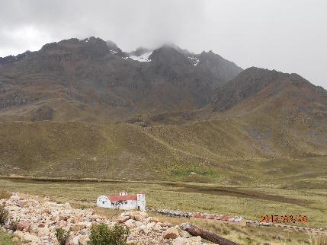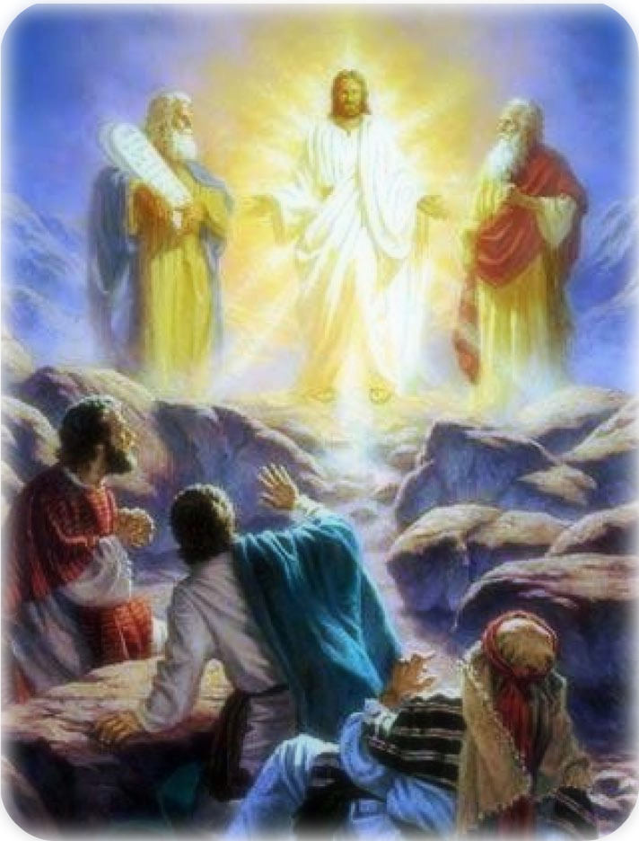

You may like to reflect on your own… It usually means that we have a sudden awareness or appreciation. Sometimes that awareness is a palpable feeling of the presence of God in our lives. It may be in the “still small voice” just as much as in the grandeur of the mountain peak or the noise of daily living. Wherever you have experienced it the event may have led to a change in you, or your understanding. Can you imagine how the disciples felt on the mountain top and seeing Moses and Elijah with a dazzling Jesus? Wouldn’t you have been terrified too? Peter made the connection that God was ushering in a new age, “The Day of the Lord”, which would be during the Feast of Booths and hence his comments. But the time was wrong because Jesus had more to do – he had to “suffer and be rejected” – and in doing so transformed the relationship between the human race and God. Jesus did indeed herald a new age and one that continues to develop. With the life, death, and resurrection of Jesus comes the promise of God’s eternal love for all of us, no matter what. It transcends all human endeavour. It is there in every experience that we encounter. God knows what we face – the sad and difficult times as well as the wonderful and happy ones.
On the mountain, the disciples had an amazing and life-changing experience. Jesus told them not to tell anyone else because of what lay ahead. That must have been difficult for them too. Could you have kept such a secret? It was the beginning of their understanding of who Jesus was and what he would do. It was surely overwhelming at first. If they hadn’t seen the transfiguration with their own eyes would they have believed it? No wonder they needed to be witnesses.
God told the disciples to listen to Jesus, and we need to listen too. Of course, it could be risky! We may see things in a new light. We may be challenged to do things that we don’t want to do or feel that we can’t. We always have a choice. We can listen or we can turn a deaf ear. Jesus chose ordinary men to be his disciples – and look what they achieved! They can’t have known at the outset but their whole lives were turned upside down and they celebrated what God, in the person of Jesus, did for them.
On the mountain Jesus’ authority was once again confirmed by God, and witnessed by the disciples, but he didn’t stay up there. As did Elisha, he came down the mountain and taught the people. He showed God’s love to them by his teaching and miracles, but also by being himself, by the way he spoke and by the way he cared for anyone and everyone. It was not his fault that some chose not to listen or thought they knew better – the scribes and pharisees for instance. In modern times there are many who choose not to listen or who think they know better, until the chips are down. Now, as much as at any time, people need to hear of God’s love, freely available for all. When we work with God not only do we feel better but the world becomes a better place too. Our effect may only be on one person, but that is enough. It can become an infection of the very best kind! And remember, there are many ways of communicating!!

Hymn: SoF 829 - I stand amazed in the presence - https://youtu.be/nN9CJrp0jwo
Or: StF 343 - All my days I will sing this song of gladness - https://youtu.be/m3ILdnift8c

Prayers for Others: Lord, so often we feel inadequate, not up to the task in hand. We think others will be better. Help us to accept that you do not ask us to do more than we are able. Enable us to listen to your voice of love, encouragment and enablement. Help us to see how we may make a difference for the better.
Lord we pray for those who are taking time and giving of themselves to help people in need. We remember those struggling to provide care on the front line of the health service. We read of abuse that they receive and still they press on, caring for those who are suffering. We pray that they will be sustained by your love and the support given by others. We remember, too, all of the other key workers, some of whom are putting their lives at risk. We thank you that vaccines are available now and pray that they will be taken up by as many people as possible and curtail the current pandemic.
We pray for people who are struggling because of the lockdown – those made redundant, and/or struggling with debt; those who are lonely; the parents and children finding home schooling difficult; the victims of abuse and mental stress; those who have not been able to leave their homes since March; those who are frightened, especially if they need medical care but do not feel able to ask for it.
We pray for all leaders of people everywhere – politicians, teachers, religious leaders – and ask that their decisions will be fair and just, and in accordance with your will. May there develop a better understanding and accord between nations, creeds, races and individuals. We pray for those suffering because of power struggles, brutal dictatorships and war; those with no access to sufficient food, water, and medicines.
We pray for ourselves and those we love. May we have the assurance that comes with being your children. In Jesus’ name. Amen

Hymn: StF 706 - Longing for light - https://youtu.be/ZeyWIO6DFMo

Benediction: StF 459/H&P 62: Captain of Israel’s host and guide: “Our strength, Thy grace, our rule, Thy Word;
Our end, the glory of the Lord.” The transforming love of God be with us all now and always. Amen

