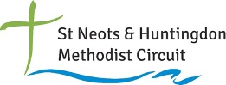
Worship Sheet for 31st January 2021 prepared by Colin Webber
of Berkley Street Methodist Church, St Neots
(Credit to Roots for inspiring elements of this worship material)

Amazing, Astonishing, Astounding … Jesus!

HYMN
StF 357/H&P 264 - Jesus - the name high over all
https://www.youtube.com/watch?v=ZSeAYKG-8Ko

PRAYERS OF PRAISE AND THANKSGIVING & CONFESSION
Lord, thank you that you break into our world to bring healing and wholeness. That, if we choose to look, you continue to surprise and astonish us. Give us wisdom to see your words and deeds. Give us courage to be your mouth and hands. Loving God, we lay before you the good things we've enjoyed this week. Help us to embrace the fun, laughter and delight that comes our way. We lay before you the things we've struggled with this week. Help us to find comfort in our sorrowing, and strength to find new ways of living. We lay before you the things we've done that we would like to undo. Help us to live in your forgiveness and mercy. Amen.

READINGS
DEUTERONOMY 18.15-20; PSALM 111; MARK 1.21-28; 1 CORINTHIANS 8.1-13

REFLECTION (PART 1)
Deuteronomy shows that the main sign of a prophet is the matching of words and experience. Moses was Israel’s teacher and led them out of slavery. Mark reveals this to be true of Jesus too. People are challenged and life is changed as heaven breaks in and abolishes hell. What Jesus says, does, and is, reveal his authority and power.

If we concentrate on words (opinion, preaching, and teaching) will heaven break in? The people in the synagogue compared Jesus with the scribes – men of words. They saw that because Jesus acted as well as taught, he represented something more potent than the scribes. What happens to a church community that speaks but rarely acts? We know that God sometimes uses non-believers to ensure God’s activity in the world.
If we concentrate on action and don’t speak clearly of what we believe God expects, can we miss the bigger picture? Mark would have understood Jesus in terms of his death and resurrection. This was so significant that he was careful not to give the impression that Jesus was just a ‘wonder worker’. If people only see Jesus in this way, it misses the point – he was the messiah. What are we in danger of missing if we concentrate either solely on social action or solely on ‘signs and wonders’?

Mark frequently tells us that Jesus taught but interestingly records much less of his actual teaching than the other gospel writers. Perhaps that is because of the connection Mark makes in this story between teaching and power: this is ‘new teaching with authority’ manifested not just in Jesus’ words but in his power to heal – this is kingdom authority! And it is heading in a unique direction, overthrowing not rival rulers but the power of Satan over people’s lives.

PICK AND MIX HYMN(S)
H&P 789 - Christ for the world, we sing!
https://www.youtube.com/watch?v=cG7iSIMANCI
All to Jesus I surrender
https://www.youtube.com/watch?v=7x2IpLSfqp8
H&P 269 - O Jesus, King most wonderful
https://www.youtube.com/watch?v=FqbgI2b67Ak
Jesus put this song into our hearts
https://www.youtube.com/watch?v=-w_QwKAdd8A
StF 56/H&P 499 - King of glory, king of peace
https://www.youtube.com/watch?v=ypqaV5fKP8Q
Jesus we enthrone you
https://www.youtube.com/watch?v=-8MrZj_mBx4

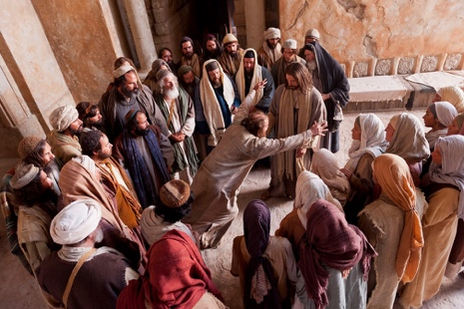
REFLECTION (PART 2)
Jesus’ ministry had begun. He had been baptised and had called disciples. Then he went to the synagogue. Jesus did not go to an alien context, but started from his own. He offered new insight and understanding of his own tradition and people were astounded. This did not bring harmony but discord. The man with an unclean spirit caused a disturbance. Jesus brought healing and people were amazed. Imagine hearing something very familiar but someone adds a new twist, a deeper insight, revealing something not seen before. Imagine this person working for healing and wholeness in front of you. ‘What is this?’ the people of the synagogue asked. Their encounter with Jesus provoked a reaction. Indifference was not on the agenda. Do people still react to Jesus in the same way today?

Think of words or phrases that describe Jesus’ impact on you.

We can recognise that Jesus is the ‘holy one of God’ but is it possible to feel astonishment like the people in the synagogue? Do we allow ourselves to be ‘wowed’ by Jesus? How can we follow Jesus and amaze and astonish? Jesus started within his own context. Maybe this is our starting place too. Jesus’ fame spread after this incident. Some are called to tasks that ensure fame or notoriety, but others are to stay and serve God where they are. What might this mean for us? What risks might we have to take? How can we engage our imaginations and creativity in causing a bit of a stir for Jesus?

Allow these kingdom truths to shape your reflection and prayer in response to Mark today.

ACTIVITY
Think of an issue such as a current world event, or one which is significant for the local community or the church. What words and phrases link with the subject? Write them on a large mouth shape drawn on paper. What actions could be taken to address the situation? Write these on a hand shape.

PRAYERS OF INTERCESSION
Thank you that you care for us. Because you care for us, we don't need to worry.
Thank you that you are kind to us. Because you are kind to us, help us to be kind to others.
Thank you that you have time to listen to us. Because you have time for us, help us give time to others.
Thank you that you help us. Because you help us, help us to help other people. Amen

THE LORD’S PRAYER
HYMN
I want to walk with Jesus Christ
https://www.youtube.com/watch?v=5c8-2D55lYE
The kingdom of God cannot arrive without Jesus and where he is, there the kingdom is.
Where are you today with the call of God on your life?

