Worship Sheet for Sunday 18th October 2020

Call to worship (from The Vine)
We draw near to you in worship with this offering of praise, our prayers for those in need and our lives dedicated to your service.
Hymn Guide me O thou great Jehovah https://www.bbc.co.uk/programmes/p08bf3vl

Prayers of praise, confession and thanksgiving (taken from Roots)
O Lord, we honour you for your glory and strength.
We praise you for your greatness.
We bless your name for the salvation you offer us.
We worship you and give you thanks.

We confess that although we are stamped with the image
of God, sometimes we spoil God’s image by the way we live,
by what we say and what we do. Lord, have mercy.
We confess that although we are stamped with the image
of God, sometimes we ignore God’s image in others,
and belittle them by our words and actions. Christ, have mercy.
We confess that although we are stamped with the image
of God, sometimes we hide God’s image from others,
by pretending that we know best. Lord, have mercy.
Forgive us, and renew your image stamped on us,
that we may be more like you in living and loving.

Thank you, God, for those who shared their faith with us,
who played a part in bringing us to know you,
who have nurtured our faith and loved us. Amen

Read : Psalm 96

Hymn : 10,000 reasons https://www.youtube.com/watch?v=o2M58JuV-FU

To think about
- What do you receive per day in your pocket money, your wage, your salary or your pension How much is your day’s pay worth to you ? Can you feed yourself and others with it or do you have money for little luxuries ? Are you able and willing to give some of it away ?
- What would a coin minted in your honour have on it ? Which of your roles, tasks and characteristics would you choose to have stamped on to such a coin ? What would you want others to know about you ?
- How can you be sure that you are giving to God what is God’s ?

Read: Matthew 22 verses 15-22 which includes these words ¹⁹ Show me the coin used for paying the tax.’ They brought him a denarius, ²⁰ and he asked them, ‘Whose image is this? And whose inscription?’
²¹ ‘Caesar’s,’ they replied.
Then he said to them, ‘So give back to Caesar what is Caesar’s, and to God what is God’s.’

Reflection
Since March 2020, even greater use is being made of debit cards, cheques, paying by standing orders or BACS but in Jesus’s day, although we have written documents which indicate exchange of goods, many items were paid for with the metal coins people carried with them.

The Pharisees brought Jesus a denarius. The Romans allowed the Jews to use their own local money but it had no value outside of Judea. As far as denarii are concerned, these are Romans coins, and even though you can find gold and bronze denarii, the Pharisees probably brought Jesus a silver denarius like the one shown below
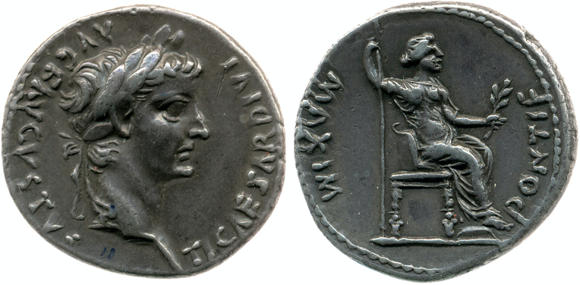
© The Trustees of the British Museum.

On it, we see Tiberius (the emperor at the time when Jesus lived) on one side and a woman (perhaps Livia, Justitia or Pax) and the words “Pontifex Maximus” which means High priest marked on the other. Tiberius held this political and religious office.

Leaders in the ancient world often used coins as pieces of propaganda to advertise themselves, to ensure that the citizens knew about them. The message they chose was punched or stamped on to coins minted in various places across the Romans Empire. Coins were stamped or punched with a stamp and made by craftsmen whose work was well respected especially if they were involved in the final stage of engraving by careful handwork to add details and lettering to the impressed coin. As in the case we see above, a head or portrait was frequently chosen for the face of the coin and the details like a helmet for a great leader or a toga for a politician in the senate communicated status.

For ordinary people, this coin represented the wages of a man who worked all day in the vineyard, for example. This working wage was enough for the worker to feed his family but not enough for luxuries. Significantly, the coin is brought to Jesus as the coin used for paying taxes to a foreign power, taxes which crippled the ordinary Jewish people and pushed many into poverty.

“So give back to Caesar what is Caesar’s, and to God what is God’s”. The answer the Pharisees and those listening received amazed them. It’s a clever but also a revealing answer. Christians live in the real world, facing the same challenges as others, paying the taxes charged of us, contributing to the local economy and community and distinguishing secular leadership from God’s. We can repay the services provided for us by the state by obeying the laws and making our returns to the tax office but there is no monetary price we can pay to God for what Jesus has done for us. Death on a cross is not a sacrifice we can repay. The reassurance of forgiveness for those who are truly sorry is not a gift we can reimburse. God’s grace and love are priceless and we can do nothing to earn them. They are free. What we can give God is of a completely different order. We can respond to God’s call by bowing down and praising his faithfulness and goodness, by thanking him for his blessings, grace and forgiveness and confessing out sins and then living our lives focussing on God, being obedient to his call and giving sacrificially. If we love God we will also love our neighbour as ourself and give generously to meet others’ needs from whatever abundance or meagre provision we have for the day: be it money, time, energy, effort or resources of other kinds.

Read : 1 Thessalonians 1 verses 1-10

Prayers of intercession (adapted from Roots)
Loving God, we thank you for all who respond to your call to work as a result of their faith.
We pray for those who are inspired to work in countries other than their own.
We give thanks for those whose labour is prompted by love of you and of their neighbours.
We pray for those who work in health care, those who look after people in residential care,
those who support their families.
We give you thanks for those whose endurance is inspired by their hope in the Lord Jesus Christ.
We pray for those who struggle through poverty or injustice, for those who are persecuted for their faith, who have been imprisoned.
Lord, in your mercy, hear our prayer. Amen

Hymn : In Christ alone https://www.youtube.com/watch?v=oKJfs8C14yc

Concluding prayer
As we conclude our worship today, may we be refreshed in our faith by our encounter with you, Lord.
May we be determined to tackle whatever we meet this week in your strength and not in our own.
May we be eager to follow Jesus, ready to be filled with your Holy Spirit, and seek to share our blessings with others. Amen

(With thanks to Pauline Zähner of Hilton Methodist Church for preparing this week’s material)

