PRINTED WORSHIP MATERIAL FOR SUNDAY 4TH OCTOBER
(Credit to Roots for inspiring the prayers and to Dr Nigel G Wright for inspiring the reflection)
Prepared by Colin Webber of Berkley Street Methodist Church, Eynesbury, St Neots
The stone that the builders rejected is our cornerstone. Come to offer your worship.
HYMN
All Heaven Declares https://www.youtube.com/watch?v=l8y86qnKkmM

PRAYERS OF PRAISE AND THANKSGIVING & CONFESSION
Lord, we cannot earn your love. You lived and died and rose for us. All that we do is as nothing in comparison. We draw near in faith, for we would know you. We offer our righteousness, for we would love you. We enter your holiness, for we would become like you. Amen.

When we adopt the values that the world offers, and not the way that you offer…
Your kingdom come; your will be done.
When we ignore your truth and go our own way…
Your kingdom come; your will be done.
When we base our living on the trivial and overlook the eternal…
Your kingdom come; your will be done.
May your kingdom come through our repentance, through our forgiveness and through our renewal.
Your kingdom come; your will be done.
Amen.

ACTIVITY
Draw two lines on a sheet of paper, one horizontally through the centre, the other vertically, dividing it into four. In the top left section, write ‘I am sure’. In the top right, ‘I am not sure’. In the bottom left, ‘I hope’; and in the bottom right, ‘I fear’. Spend time thinking about yourself and your life, and then write or draw anything that comes to mind for each section. Continue as long as you want, then close your eyes and simply say, ‘God, please guide me.’ Open your eyes and silently read through all you have written/drawn, seeking to listen for what God is telling you. Thank God for his wisdom and love.

READINGS
PSALM 80.7-15, ISAIAH 5.1-7, MATTHEW 21.33-46, PHILIPPIANS 3.4B-14

REFLECTION
Another Sunday, another vineyard – we know how Jesus loved to wrap his truths in tales of events and places that were prominent in the culture and landscape. The readings from Isaiah and Matthew (and the Psalm) are linked by strong vineyard imagery. In all three readings, the challenge posed is to see ourselves as we really are – that means, as God sees us – and not be fooled by who we think we are.

Justice is important to Isaiah, but what does it mean? This passage may seem to start like a romantic song (cultivating a vineyard used as a metaphor for courtship) reflecting the devotion and despair of love. But suddenly the vineyard is identified with the listeners and the vintner turns out to be God. Justice means to pass on the good that He has already provided – the consequence of the love and care that God bestows on his vineyard should be people sharing God’s blessings with each other, especially those less fortunate and returning it to him in praise, akin to yielding good fruits and maintaining a circle of blessing. Isaiah accuses the people of Israel of breaking this circle.

Jesus’ audience would have made the connection with Isaiah 5.1-7. They know the vineyard tradition and what Isaiah did with it. They probably feel comfortable that they know where Jesus is going with his parable – telling them of a dark event of the past, one that everyone knows about, but will end by telling them, ‘it’s all right, things are different now’. Except, Jesus doesn’t do that. Instead, the ending in which the tenants are driven out and new tenants brought in is deeply disturbing: more disturbing than Isaiah’s changed ending was in his day.

Many parables have a single clear message, but this one in Matthew is more of an allegory.
Vineyard = Israel, usurped by those who think they own the nation.
Vineyard Keepers = the established leadership, criticised by Jesus (v45).
Servants/Slaves = Prophets, continually rejected and ill-treated.
Son = Jesus, to be rejected and killed outside city walls.
If we need a reminder of the anguish of Christ’s passion, perhaps George Herbert’s poem will help!

The Agony - George Herbert
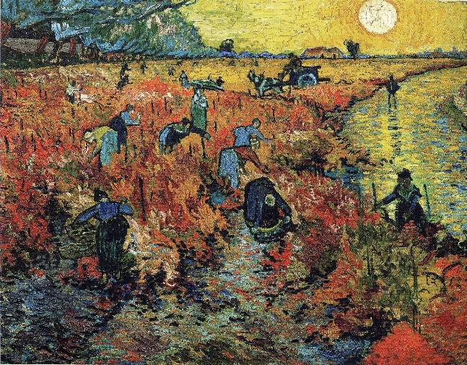
Philosophers have measured mountains,
Fathomed the depths of the seas, of states, and kings,
Walked with a staff to heaven, and traced fountains:
But there are two vast, spacious things,
The which to measure it doth more behove:
Yet few there are that sound them; Sin and Love.
Who would know Sin, let him repair
Unto mount Olivet; there shall he see
A man so wrung with pains, that all his hair,
His skin, his garments bloody be.
Sin is that press and vice, which forces pain
To hunt his cruel food through every vein.
Who knows not Love, let him assay
And taste that juice, which on the cross a pike
Did set again abroach then let him say
If ever he did taste the like.
Love is that liquor sweet and most divine,
Which my God feels as blood; but I, as wine

Jesus draws upon Psalm 118 and likens himself to a stone rejected by builders because it does not seem to fit – his words and actions have alienated him from those who hold power in Israel, despite or because of his popularity with the ordinary people. Yet he is destined to undergo a dramatic reversal of fortunes to become the capstone (completion) or cornerstone (foundation) of God’s new temple, his crucial significance in view. Elsewhere, the same words interpret the resurrection – the rejected one becomes the exalted one. With God, all things are possible, not least through his Son. God is not daunted or thwarted by the most unimaginably painful scenarios …

PICK AND MIX HYMN(S)
My song is love unknown https://www.youtube.com/watch?v=CRUp5JiRFu0
O Lord, hear my prayer https://www.youtube.com/watch?v=NhmWdhiVi9Q
You are the vine (Daniels & Rigby) https://www.youtube.com/watch?v=sicaArhwbIw
Safe in the shadow of the Lord https://www.youtube.com/watch?v=cB9s89jL-ls
The Spirit lives to set us free https://www.youtube.com/watch?v=SDcbYk-9C-Y
PRAYERS OF INTERCESSION
We pray for those whose work is pleasing to God. We remember those who work for peace and reconciliation: for the United Nations; for ACAS; for Relate…
Lord, look with kindness on those who live in righteousness.
We pray for those whose work is pleasing to God. We remember all who seek to feed the hungry:
those who work for aid agency projects; those who raise money to fund projects; those who work for food banks, for the Trussell Trust… and all who give that others may eat.
Lord, look with kindness on those who live in righteousness.
We pray for those who live in faith: for those who quietly keep an eye on their neighbours; for those who go shopping for others; for those who visit and those who offer lifts.
Lord, look with kindness on those who live in faith.
We pray for those who live in faith: for those who pray without a fuss; for those who give generously of themselves; for those who quietly witness to the love of God within them.
Lord, look with kindness on those who live in faith.
Amen.

THE LORD’S PRAYER
HYMN
When I Survey the Wondrous Cross https://www.youtube.com/watch?v=4_fvFfPqjO4
May we live in faith, act in righteousness, always be loved and make Jesus the cornerstone of our lives. Amen.

