This week’s worship sheet has been prepared by Pauline Zahner of Hilton Methodist Church

PRINTED WORSHIP MATERIAL FOR SUNDAY 27TH SEPTEMBER
Are we humble enough to learn greater humility?

A prayer of praise (adapted from Roots)
At the name of Jesus every knee shall bow.
Jesus, you came in the form of God, but did not regard
equality with God as something to be exploited.
You emptied yourself, taking the form of a slave,
being born in human likeness.
Being found in human form, you humbled yourself and
became obedient to the point of death – even death on a cross.
God highly exalted you and gave you the name
that is above every name.
Let every tongue confess that Jesus Christ is Lord,
to the glory of God, the Father. Amen.

Confession (adapted from Roots)
Merciful God, forgive us:
for times when we have resisted your call,
and turned away from your truth;
for times when we have not listened to your good news,
nor to the gospel values you have entrusted to us.
Merciful God, forgive us, renew us, restore us,
that we may be humble enough to learn from your example,
go where you will guide us,
and do as you would have us do.
In the name of Jesus. Amen.

Listen to and/or sing
My Lord, my Saviour
https://www.bbc.co.uk/programmes/p0616r98
Meekness and majesty
https://www.youtube.com/watch?v=Gtt52JEW_Zo

To think about

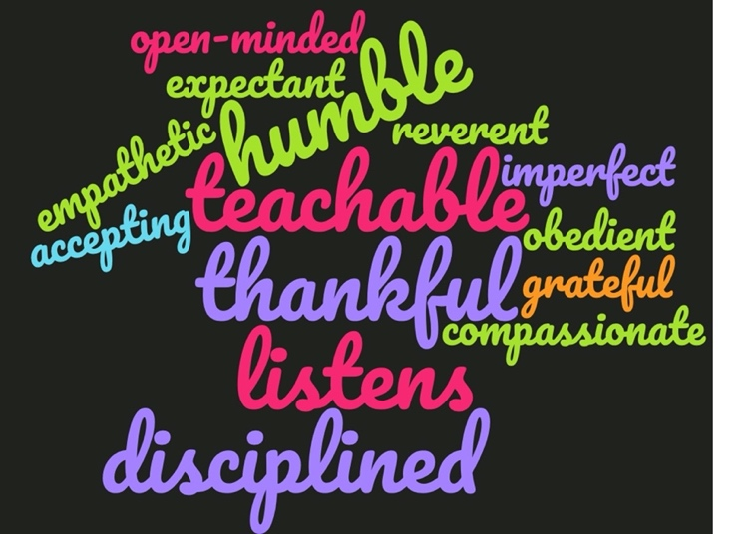 | - Which of the words in this word cloud would you say are typical of a person who is humble ?  - Why is humility viewed by Christians as so important ?  - How can we develop greater humility ?

Read Psalm 25 verses 1-9 and reflect upon it:

Reflection: “He guides the humble in what is right and teaches them his ways.”

The psalmist of Psalm 25 – we’re told it’s David – sees himself as one of the humble and we can recognise the quality of humility in him in quite a few ways.

Firstly, he doesn’t put his trust in his own strength but that of God. Before turning to his own requests, he puts God first in his psalm “To you, O Lord, I lift my soul, in you I trust”. He comes to God in a humble way, re-affirming the greatness of God. He knows that God’s perspective will be greater than his own. His hope is in God and he knows that God can forgive and forget his short comings. His gratitude is expressed in praise rather than thanks but it is lavish and from the heart.

Secondly, he has an honest opinion and assessment of himself and especially of his failings. He acknowledges that he faces challenges from external sources (which by implication, suggest he is hampered in achieving what he could otherwise achieve). He also recognises the self-imposed failings of his youth and his rebellious nature. He knows that he is not always right and doesn’t try to excuse it nor to exaggerate it nor distort it. He is not self-deprecating way and avoids blaming only others for all his shortcomings. It’s worth noting, too, that he separates sin from the sinner. He speaks with humility.

The third way in which he demonstrates his humility is by being willing to learn. He knows he is not perfect but he IS teachable and open to learning more from God. Furthermore, his humility allows him to be confident enough to be able to ask for help: “Show me…teach me…guide me..” and later “God instructs the sinners in his ways”. The psalmist has a clear understanding of what sort of learning he needs to experience. He wants not just a list of things to do, nor someone telling him what to do but he wants to see in practice (“show me”), he wants the opportunity to try out the new skills he is going to acquire (“guide me”). He wants God to enable him to learn by example and through support. He is bold in his requests as he asks (and almost tells) God to remember his covenant love and forget the past errors committed by the psalmist. In other words, he is saying, “Lord, I’m asking for what is wrapped up in your covenant”. More important than acquiring information for the psalmist is learning God’s ways and that God will forgive.

How can we develop humility?
Humility is a Christian virtue as Christ calls us to be humble. He modelled humility on numerous occasions including when he washed the disciples’ feet and when he took our sins upon himself and accepted death on a cross so that we could be forgiven. Many Christians have followed Christ into a life of humility. A very well know example is that of Mother Teresa who gave up the relative comforts of her convent to live with the poorest on the streets of Calcutta.

Like other Christian virtues (such as gratitude) humility is a discipline and needs to be conscientiously practised and developed until it becomes second nature to us. You may well find this psalm, especially the first 9 verses helpful in guiding your own prayers. Its pattern is fairly simple: surrender your heart and mind to God, lay before him the challenges from external forces, acknowledge your need of help and admit your own shortcomings before you express again your praise for what God has given us and your trust in God. Some people would call this focussing on the present, being grateful for what you have and being ready to ask for help when you need it to develop further. There is a link between gratitude and humility and everyday common sense will help us see that they are mutually reinforcing.

If we want to test out how good we are in practising humility we might do a regular check of the amount of time we spend talking to others and the amount of time we spend listening to them. By listening we come to a better understanding of the perspective of others and where their needs lie. In the end, such discoveries will make us more compassionate people. Another check might be on how often our own language includes examples of pride in what we have done and how often an exaggeration – albeit slight – of what we have achieved. How often did we deflect praise to those who helped us or supported us, the team behind us?

How might greater humility help in our communities and teamwork?
In communities and teams where humility is practised and encouraged, more positive interactions between people tend to occur. Where this is the case, teams are strengthened and empathy between individuals is increased. It is easy to see how this would result in more pleasant environments in which to live and work as well as more productive ones.

Concluding question
Are we humble enough to want to learn greater humility?

Additional reading: Philippians 2 verses 1-13

Prayers (adapted from Roots)
Prayers for others
Lord God, we thank you for all those who show us love;
For all those who bear with us when we make poor life choices,
For those who listen to us when the decisions we have made have resulted in things going wrong,
For those who help us find out more about your grace and forgiveness, learn about the transforming power of your love, develop new skills so that they can share your love with others in more confident and effective ways.
Loving God, we pray for all in authority that they might have the insight to discern their true strengths and weaknesses, the humility to acknowledge when they need support and the wisdom to ask for help when they need it. Amen

Prayers for ourselves
Jesus lived a humble life to show us God's way.
Help us to put others first and ourselves last:
Help us to discern when it is right to lead and when it is right to listen:
Help us to honour the poor and fight for the weak:
Help us to make the right choices and use our time well:
Help us to become more like Jesus each day:
teach us your way of love.
We ask these prayers in the name of Jesus Christ
who humbled himself and became obedient to the point of death –
even death on a cross. Amen.

Listen and/or sing : May the mind of Christ my Saviour
https://www.youtube.com/watch?v=dRTLocMzTvs

Sending out prayer
May the mind of our Saviour, Jesus Christ, live in us,
so that his love guides all we do and say.

