Worship Sheet – Sunday 2nd August 2020

Opening Prayers (from The Vine)

Lord of compassion, we direct our attention to you knowing that you are always attentive towards us. Thank you for your love which sustains us and your grace that restores us.

Forgive us for the ways we have fallen short in our love and grow in us a desire to be more like you. Let your words of grace ring out to us, that when we ask, our sins are forgiven.

Jesus among us, we thank you for your presence and the work of your Spirit within us.
That you promise to be with us and grant that we are never alone.
Thank you for drawing us to you through your love and illuminating our hearts and minds with your truth.

Father over all, the whole of creation witnesses to your great works and rejoices in who you are. You are worthy of our adoration and we join our voices to bring you our praise.
To you belongs all glory and splendour and we magnify your holy name. Amen.

God’s word: Read one or more of these passages and allow time and space for God to speak though his word: Genesis 32:22-31, Psalm 17:1-7,15, Romans 9:1-5, Matthew 14:13-21.

Reflect: Read the passage Matthew 14:13-21.
Notice the instruction: “Don’t send them away. Feed them from your own resources.” How does this instruction speak to you? This miracle encourages us not to be deterred by the obvious inadequacy of our own resources, because the Kingdom operated a multiplication factor way beyond our imagination.

Look and think: Notice your reaction to this picture. Can you place yourself somewhere in this crowd? How does it feel to listen to Jesus teaching- what is he saying to you? Are you completely satisfied? How much is there left over to ponder further? From here – what is Jesus calling to you?

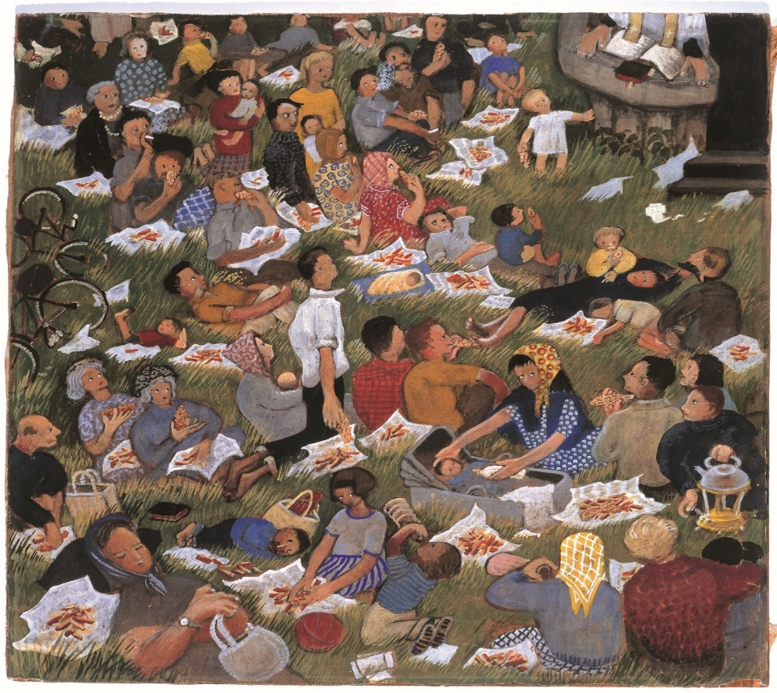

Eularia Clarke sets the feeding of the five thousand in modern dress and follows Matthew’s account in which women and children are present. The multitude has sat down in the grass, as Jesus requested, and is eating, not the fish and bread referred to in the Bible but, as in so much of Clarke’s work, a twentieth Century equivalent, fish and chips. The scene is more reminiscent of a church picnic than the biblical miracle. Tea is brewing in the lower right corner, bicycles and footballs are discarded, children and babies are remarkably well behaved, some people doze, others pay attention to the priest – or Jesus (whose head and shoulders are uncomfortably cut off by the edge of the painting). The artist said: ‘I daren’t paint Christ, I put in a pulpit, the priest is reading the notices before the sermon.’
Commentary based on A Guide to the Methodist Art Collection.

Prayers of intercession (from The Vine)

We take as our refrain for our prayers of intercession – an acknowledgement that as we pray, we seek also to be changed, to be motivated to act.

Let us pray.

God of all grace, we bring you ourselves. We bring you our lives, as they currently are, with all that is broken and wrong, but also much to be grateful for and to celebrate. Use us, O God, to build your kingdom, to seek peace in our world, to build communities of love.

May we follow in your way, O God.

God of all grace, we bring you our churches, caught in this strange ‘in between’ time, as we reflect on the painful experiences of lockdown, and how we can best serve our communities and our world over this summer and into the year ahead. Show us how to create safe spaces, spaces where people can grieve, can find healing, can meet with you and be transformed by your grace.

May we follow in your way, O God.

God of all grace, we bring you our nation, 2020 has been – and will continue to be – a difficult year for us as a country. This year of Coronavirus, but also a year where we have discovered much
underlying injustice and pain. We bring to you all who have been working overtime to see us through this time of crisis, and all who will need to work overtime as we seek to rebuild our communities, our economy, our relationships and our livelihoods. We bring you our leaders and all who must face difficult decisions or face up to inadequacies in our systems exposed by the process of lockdown and pandemic. Show us how to be a people of grace.

May we follow in your way, O God.

God of all grace, we pray for our world. As we look out on a global pandemic, and a world in which we have gone backwards in tackling poverty and reaching those most in need during this time of pandemic, which has affected the most vulnerable in our world more than many of us.
As we rebuild, show us how to build a world in which every person’s needs are provided for. A world where every person’s potential is fulfilled.

May we follow in your way, O God.

May I follow in your way, O God.

Show me what is mine to do.

We bring this, and all our prayers, in Jesus’ name, Amen.
The Lord’s Prayer

Listen & Sing:

Be thou my vision https://youtu.be/XiukM6WHQEQ
I stand amazed in the presence https://youtu.be/su4aF0OoMxs
What a faithful God have I https://youtu.be/4fo1UV9pfrs
Jesus I need you https://youtu.be/lKM-8CZRplI

Blessing:

Guide us, great Jehovah, as we seek to respond to your love to us. Help us be a
shining example of love in a world crying out in need. May we be Christ’s hands and
feet, by the power of your Spirit. Amen.

‘The Lord is near. Do not be anxious about anything, but in everything, by prayer and petition, with thanksgiving, present your requests to God.’ Philippians 4: 5 – 6

Blessing written by Tim Baker

