Worship for Sunday (for family worship: www.rootsontheweb.com/familiesathome14june)

Pause in God’s Presence:
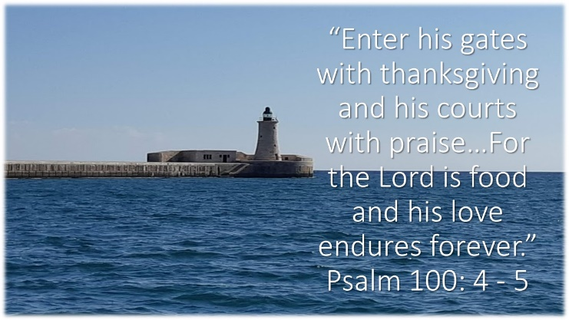

Sit for a few moments with this picture. As you come into God’s presence what is God’s invitation to you today? Know that you belong to God, hear his call ‘Come, just as you are; Come listen to my word, be changed by my Spirit.’

God’s word: Read one or more of these passages and allow time and space for God to speak though his word: Psalm 100, Exodus 19: 2 – 8a, Romans 5: 1 – 8 and Matthew 9: 35 – 10: 8

Explore God’s Word:

Look and think:

What does this picture say to you about the life of discipleship? Stepping out of the box may be akin to travelling in unfamiliar territory – how do you feel about following Jesus beyond your comfort zone? What helps you to step out of the box? What challenges you? What are the benefits/risks?

Reflection: read the following slowly and be alert to where God is drawing your attention. Sit with Him and ponder what His meaning might be.
You are the one who walks with us in our troubles,
yet we sometimes cannot find you.
We have walked through time together and have considered our own place and our own lives.
So now we come and lay ourselves at your feet.
We know our faults and problems.
We know the way we live and work,
the way we are part of this community and this church.
Awaken us anew.
Cause our spirits to stir and arise.
Help us to know your forgiveness and your love, and bring us to repentance as our own grateful response.
Talk to us in the silence of our hearts,
and may we find you again
as the one who is all in all,
the one for whom we live,
the source of all our being
and the reason we are here.
Open our hearts again, we pray.
And the people said: Amen!
(© from Roots material)

Prayers
God, present in every moment and circumstance we lift our world to you today, knowing that you have called us to do so and knowing that you care about even the smallest detail of that world.

We lift to you all who suffer today at the hands of others, through war, greed, the abuse of power, or the abuse of words. May they find you standing with them, giving them strength. May we your people upholding all and enable each to be heard, that your love may be seen and known.

We lift to you all those who find themselves in positions of authority today, whether it be by choice, or because their skills have been recognized and needed, or because there is no one else available. May they seek wisdom in the right places and have the humility to know when they need help.

We lift to you all who suffer today as a result of this pandemic; through sickness, through the loss of loved ones, through the anxiety of not knowing what the future entails or through the exhausting workload of caring for others. May they know comfort, healing, reassurance and hope.

And we lift to you all those known to us personally who are in need today … (name them) … May they find grace, healing, and blessing.

We bring all these prayers in the name of Jesus who taught us when we pray to say …
The Lord’s Prayer

Listen & Sing:
Faithful one https://youtu.be/7PjSO5Ihl0M
We will walk with God https://youtu.be/YKybxg99fUc
Lord of all hopefulness https://youtu.be/b8mti7VL3gg
Brother, sister let me serve you https://youtu.be/07FBSrx5Oq4

Blessing:
To heal and serve we go; In God’s strength and guiding we go; With love and hope we go. In your going the peace of God wrap you round, confirm you as precious and sustain your sharing. Dear Friends, the Lord bless you. Amen.

