Worship for Sunday (for family worship: www.rootsontheweb.com/familiesathome31may)

Pause in God’s Presence:
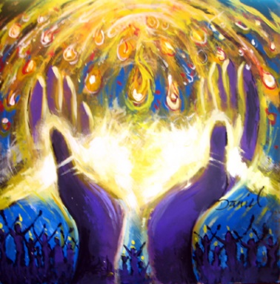

Sit for a few moments with this picture. As you come into God’s presence what is God’s invitation to you today? In time with you breathing in/out pray: Come, Holy Spirit, Breath of God.
Holy God, pour out afresh your Spirit, fill us to overflowing, unite us even though we are dispersed, release your power and make us new. Come, Holy Spirit, come now. Amen.

God’s word: Read one or more of these passages and allow time and space for God to speak though his word: Psalm 104: 24 – 34, John 7: 37 – 39, Acts 2: 1 – 21, 1 Corinthians 12: 3b - 13

Explore God’s Word: Engage with this meditation (© from www. ignatianspirituality.com/imaginative-prayer-pentecost by Vinita Hampton Wright). Imagine you had been there how would you retell the events?

After Jesus ascended to the Father, all of us who followed him decided to stay together. He told us to wait for the Holy Spirit. We weren’t sure what that meant, really. What would it look like, feel like? The Holy Spirit visited the prophets in strange ways—in visions, with powerful speech, even with great miracles.
In Jesus’ company, we had indeed witnessed miracles. We told stories, often, of when he healed this person or cast out a demon from that one. We recounted the story of Jesus feeding thousands with a few loaves and fishes.

The biggest miracle, of course, was his Resurrection. That was more than a miracle; it changed the world forever. It changed us, down to our very bones and breath.

What do I remember most fondly about traveling with Jesus? Was it his stories? He had a story for just about every situation! Was it the way he looked with great kindness on a person, no matter who that person was or what he’d done? All we could do now was tell stories of what had already happened—that, and pray. We prayed as Jesus had taught us. And we waited.

What are we waiting for? How will we know that the Advocate has come to us? Will we know for certain, or will it be another one of Jesus’ puzzles or parables? The Feast of Pentecost arrived, and still we remained gathered like sheep awaiting the shepherd. We observed our Pentecost prayers and rituals, continuing to act like the observant Jews we were. But something was missing, and we didn’t even know how to describe it.

What does a community need, when it has understood a new and revolutionary truth? Do we need better understanding? Do we need a plan? Do we need, more than anything, the courage to keep believing and telling what we know? On the Feast of Pentecost, while we prayed together, the room suddenly filled with wind that seemed to come from an ocean or a desert. Or a cave or a mountain. It was fresh and cool yet weighted with unnameable fragrance and crackling like fire. The two small windows and the seemingly calm weather outside could not account for this roaring, invisible, electric rush of air.

What is happening? Are we to be taken up in a whirlwind, as Elijah was? Will we go now to be with our Lord, wherever he is? We prayed louder and with urgency. Surely God would protect us from whatever was happening just now. At one point all of us were saying, together, the prayer Jesus had taught us: “Our Father . . .”

Then our communal prayer burst into a hundred prayers at once. Our words had begun in unison but now reproduced themselves in odd yet fervent lines of syllables. After a few moments, we realized that we were not saying the same words. In fact, we were not even speaking the same language.

What is going on in my mouth? I think a thought, and my tongue and lips form the thought on their own, in words I cannot perceive yet know to be true. Each one of us was praying in an excited voice, in a distinct language. And we were proclaiming this new story of the risen Christ with eloquence we could not have imagined moments before. With our minds we could not translate, but our hearts knew exactly what we meant.
Who’s knocking on the door? Oh—they’ve pushed it open, and there’s a crowd out there! Who are they, and what do they want? They seem to be foreigners, judging by their clothes.

We stopped praying so that the people out in the street, now in our doorway, could be heard. “How is that you Galileans are speaking all our languages, telling us of God’s mighty works? We’re from a dozen different countries and tongues, and yet you speak to us plainly. What’s going on here?”

Then Peter stood on a table and began to tell the story.

Look and think:
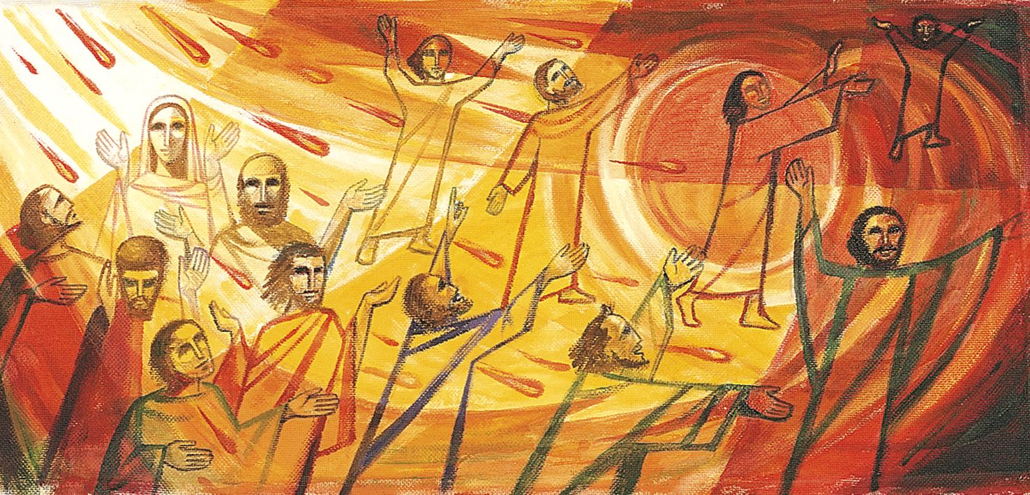

What does this picture say to you about Pentecost? What stands out to you? What nourishes you in the picture? Notice what, if anything, challenges you. What difference does the Holy Spirit make in the life of the church you attend?...and in your own life?

Reflection: read the following slowly and be alert to where God is drawing your attention. Sit with Him and ponder what His meaning might be.

Pentecost ©Malcolm Guite
Today we feel the wind beneath our wings
Today the hidden fountain flows and plays
Today the church draws breath at last and sings
As every flame becomes a Tongue of praise.
This is the feast of fire, air, and water
Poured out and breathed and kindled into earth.
The earth herself awakens to her maker
And is translated out of death to birth.
The right words come today in their right order
And every word spells freedom and release
Today the gospel crosses every border
All tongues are loosened by the Prince of Peace
Today the lost are found in His translation.
Whose mother-tongue is Love, in every nation.

Prayers
Holy Spirit, proclaimer of peace we pray for homes, communities, and nations where there is discord and conflict. Breathe afresh into each situation and heart that peace which the world can neither give nor take away. Empower people to listen and hear one another, to respect and honour all.

Holy Spirit, herald of hope we pray for those living in despair, overcome by anxiety, circumstance, fear, loss of purpose, lack of direction, for those whose feeling of isolation has escalated in recent times. May each know your unfailing presence giving fresh strength for the next moment.

Holy Spirit, may the oneness you enjoy with the Father and the Son inspire your Church. As we take our direction from you and seek fresh ways of being church may we always seek to work in partnership with others, celebrating our similarities and learning from our differences that together we may be faithful witnesses to the love, hope and peace you offer to the world. In our Circuit we remember particularly today all connected with Huntingdon and James their minister.

Holy Spirit, breath of life we pray for those known to us who are ill at home, in hospital or hospice, those awaiting diagnoses and those living with new diagnoses. We hold before you all who are recuperating from recent procedures, and all who face further treatments. We remember those who mourn, those whose anniversaries fall in these days, those who have attended funerals or are planning funerals for loved ones. May each rest secure in the knowledge that your gaze will never be turned from them, that in every moment your provision will supply their needs.

In the name of Jesus, our risen and ascended Lord we pray. Amen
The Lord’s Prayer
Our Father ……

Listen & Sing:
Holy Spirit we welcome you https://youtu.be/-5_eGsD3gj0
Spirit of God unseen as the wind https://youtu.be/dy8AZ46GKqc
Breathe on me, breath of God https://youtu.be/MmkzSjs9eAw
All over the world https://youtu.be/UR4tE1kh-mE

Blessing:
The Holy Spirit fill you with peace and love, guide you in grace and joy, overflow through you with hope and power and the blessing of the One God surround you, those whom you love and those for whom you pray today and every day. Amen.

