Worship for Sunday (for family worship: www.rootsontheweb.com/familiesathome10may)
Pause in God’s Presence:
Be still for a moment and come into the presence of God.
We come with all that we are to hear those words…. “Do not let your hearts be troubled. Trust in God, trust also in me”. We thank you that you are a God who knows what it is like to be troubled and who speaks and reaches out to us. In times of anxiety and uncertainty, assure us of your presence, that you not only accompany us on this journey but that you also go ahead of us to prepare a place for us so that we have nothing left to fear.
We pray that we might know this peace, freedom and blessed assurance today and every day. In the name of Christ. Amen.

God’s word: Read one or more of these passages and allow time and space for God to speak though his word: Acts 7:55-60, Psalm 31:1-5,15-16, 1 Peter 2:2-10, John 14:1-4.
Explore God’s Word:
John 14 v1-4
I imagine Jesus sitting with me where I am at this moment, and I hear him saying to me “Do not let your heart be troubled”. There may be things in my life that are troubling me now: can I allow these consoling words of Jesus to touch my heart like balm? I look at Jesus as he says these words to me. What expression do I see on his face as he looks at me, as he looks into my heart?
I am being invited to trust the God who loves me and who is waiting for me. Talk to Jesus about your troubles and anxieties. Listen to him as he replies to you.

John 14 v4-14
It is consoling to think that even Jesus’s closest friends failed to understand him. He is endlessly patient. He explains again and again until we catch on. He is always ready to speak to us in prayer.
The gentle voice of God can speak to us in many ways: through friends and strangers, and through the voice of conscience within ourselves. Are you open to these channels?

Perhaps we are sometimes like Thomas: asking a question of Jesus while thinking that we will be left on our own to work things out. Lord, help me to listen to your promises, to receive your assurances, to let you remove troubles from my heart. May I bear in mind that you are with me. May I know who you are and the promises that you give.

Look and think:
Jesus is the way the truth and the life.
Have a look at the picture (colour it in if you like). Which one of the characters in this picture do you identify with most? If you are with a group of people, ask each other which ones they chose and why. Be honest, there are no right or wrong answers.
After you have done this, let God know which one you are and allow him to speak to you as if he was sitting down with you.

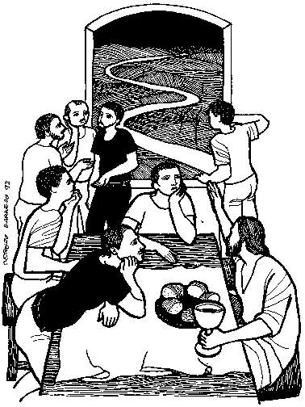

Reflection:
I like Thomas, because he is so totally honest, he comes with all his doubt and is not afraid to speak up about it to Jesus. This new hymn is called:

LIKE THOMAS LIFE IS HARD AT TIMES

Life is hard at times,
So much fear.
Hope seems lost to me,
Are you near?
I need you here beside me
For strength along the way,
So I can say, like Thomas every day,
My Lord and my God
I believe!
I believe!
Doubts can wear me down
Through the years
And my trust in you
Disappears.
I need you here beside me
For strength along the way,
So I can say, like Thomas every day,
My Lord and my God
I believe!
I believe!
When my faith is low,
Stay by me.
Let me feel your scars,
Help me see
That you are here beside me
For strength along the way
So I can say, like Thomas every day,
My Lord and my God
I believe!
I believe!
I believe!
Words and music © Heather Gallagher 2009. Revised 2015

Prayers
We pray at this time of uncertainty, challenge and isolation.
Loving God, meet us in our fear and uncertainty and hear our prayer and offer all who come to you the sure and certain hope of salvation and eternal life; be a tower of strength amidst the shifting sands, and a light in the darkness; help us receive your gift of peace, and fix our hearts where true joys are to be found, in Jesus Christ our Lord. Keep us secure in our faith, rooted and grounded in you.
Lord, in your mercy: Hear our Prayer
Father, you show the world the way to live through the words, life, death and resurrection of your Son; grant us your grace that we who follow Him may be united to proclaim by word and action your way and hope to all people. Help us to bear the fruit of your Kingdom, that you may be revealed and glorified through us as we rest secure in your love, rooted and grounded in you.
Lord, in your mercy: Hear our Prayer
Give wisdom to all in authority, guide and direct their decisions on this important day as news is imparted on the future of our current lockdown. May all that they do and say be rooted and grounded in you.
Lord, in your mercy: Hear our Prayer
Lord Jesus Christ, who in the days of your life here on earth showed compassion on the sick and the afflicted and made them whole: bless all those who are passing through illness and trials, and bless all those who are carrying on your healing work in our hospitals, places of care and our homes. Give those who care, sympathy and skill, and an ever deepening understanding of the task to which they are called, that in your mercy those who suffer in body mind or spirit may know your power and be restored to fullness for your names sake. Rooted and grounded in you, may we be as branches of the tree of life, bringing your healing and wholeness to all the people and nations of the world.
Lord, in your mercy: Hear our Prayer
In you Father we are one family on earth and in heaven. We remember in your presence those who have died……giving thanks especially to those who have revealed to us your grace in Christ.
Merciful Father: Accept these prayers for the sake of your son, Our Saviour, Jesus Christ, Amen.

This week in your prayers remember our congregation at Eaton Ford and Rev James Bamber their minister.

Listen & Sing:
Cornerstone – Hillsong https://youtu.be/a3HH__-1Zbs
Everlasting arms – Lou Fellingham https://youtu.be/XvNfjLmlviI
What a friend we have in Jesus https://youtu.be/8SCorW9r_Is
Blessed Assurance https://youtu.be/rDeiy9-t2GE

Blessing:
May God the Father prepare your journey,
Jesus the Son guide your footsteps,
The Spirit of Life strengthen your body,
The Three in One watch over you,
on every road that you may follow. Amen

