Worship for Sunday (for family worship: www.rootsontheweb.com/familiesathome3may)

Pause in God’s presence
Stop, breathe, bring the whole of you to be present to God’s presence.

Holy God of endless love, in your presence we are known and treasured. Whatever today asks of us thank you for journeying with us. In times of pain be our comfort, in moments of decision be our guide, in days of emptiness fill us with your goodness and mercy. Today and everyday may we abide with you. In the name of Christ. Amen.

God’s word: Read one or more of these passages and be alert to God’s invitation through them: Acts 2: 42 – 47, Psalm 23, 1 Peter 2: 19 – 25, John 10: 1 - 10.

Savour God’s word: Read one or more of these passages and be alert to God’s invitation through them. Sit silently with a word or phrase from one of the readings.

Explore God’s word –
In this time how might you allow God’s word to shape you? In place of a sermon be creative and reflective. Here are just a few ideas:

Colour – prayerfully colour the picture below. How is God speaking to you through it? Remember how God provides for you and give thanks. Rejoice in the rest He offers. Relax in His care.

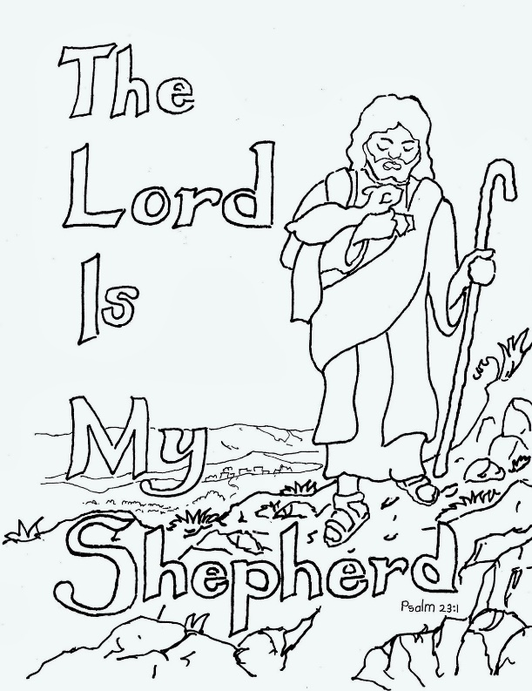

Pray
Gracious God, you care for me; I need nothing more.
Hear the cry of those who are hungry;
hungry for justice, and dignity, hungry for freedom, and love.
You lead me into a haven of peace and rest.
Hear the cry of those who are alone;
those who grieve a relationship broken by death or human failing,
those who live in the isolation of a hospital room, a prison cell,
a frail body, a confused mind.
You breathe new life into me and lead me in new ways.
God whose breath is life itself,
we pray for a just and caring use of your creation;
a fair sharing of its abundance, an ethical searching of its mysteries.
You are with me, and comfort me,
even when the darkness of the world looms large.
We pray for those who seek the truth;
those who cannot speak, and those who cannot be heard,
that the light of your Word
may shine in the darkness which overshadows their lives.
In the face of those who trouble me
you provide for me, and pour out your blessings.
Hear the cry of those trampled by racial or religious intolerance,
disoriented by homelessness, defeated by unemployment;
God of justice and compassion you are with me always
and have promised to sustain me all my life.
Enlarge our vision of life, and make us bold in our hope,
Father, Son, and Holy Spirit,
let our cry come to you;
. . . and with the saints in every age we pray,
Our Father in heaven . . . . .
©The Billabong website.

This week in your prayers remember our congregation at Buckden and Rev Pam Siddall their minister.

Look and think
The Good Shepherd calls you by name and sends you out not alone but accompanied –
in right paths and dead ends;
even in dangerous and darkest of places
He is with you – the Beloved goes ahead of you.

What does this picture say to you about Christ, the Good Shepherd? How is Jesus’ abundant life present for you today?
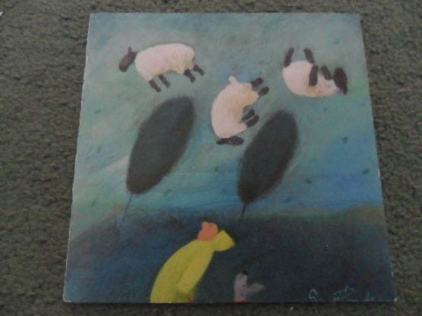

Read: A Reflection
PASTURE by Andy King
There is a place we can find, a good place
like quiet meadows where flowers spread,
like green grasses by gentle streams;
a place where the heart feels nourished,
where the mind is hopeful, unhurried,
where the spirit is glad and at peace.
We’ll name this place fulfilment,
we’ll name it healing and thankfulness,
we’ll name this good place pasture
for there we seek to feed.

And there is a voice we can hear that calls us,
a gentle voice, melodious,
a voice like songbirds and laughter,
like a mother comforting her children,
like a shepherd calling his sheep.
We’ll name this voice acceptance,
we’ll name it mercy and forgiveness,
we’ll name it the voice of God’s love,
inviting us gently to feed.
It invites us to enter pasture
when we think we’re too hurting to listen,
too angry or grieving or fearful
to hear the voice that calls us to peace.

It invites us to enter pasture
when we’re sure we’re too busy to listen,
too burdened or worried or pressured
to hear the voice that calls us to peace.

It says: Come in and go out and find pasture.
It says: We are safe with the shepherd of all sheep.
It says: Meadows await us, in this moment.
It says: Rest in love. Where you are. Joyfully feed.

Listen/sing
The Lord’s my Shepherd – Stuart Townend https://youtu.be/pN4tPkX0MG0
In heavenly love abiding https://youtu.be/8QZEGD1_Iu8
I will sing the wondrous story https://youtu.be/nAcpYr9I6Tk
God will make a way https://youtu.be/Y4DgESWtCus

Blessing
The Mighty Father shield you in the shadow of his wings; The Good Shepherd guide you and refresh you; The Holy Spirit strengthen you and affirm you and the blessing of the One God envelop you, those whom you love and those for whom you pray this day, this week and always. Amen.

