Worship for Sunday 26th April 2020 (for family worship): rootsontheweb.com

- Look and think: A Painting from the Methodist Art Collection.

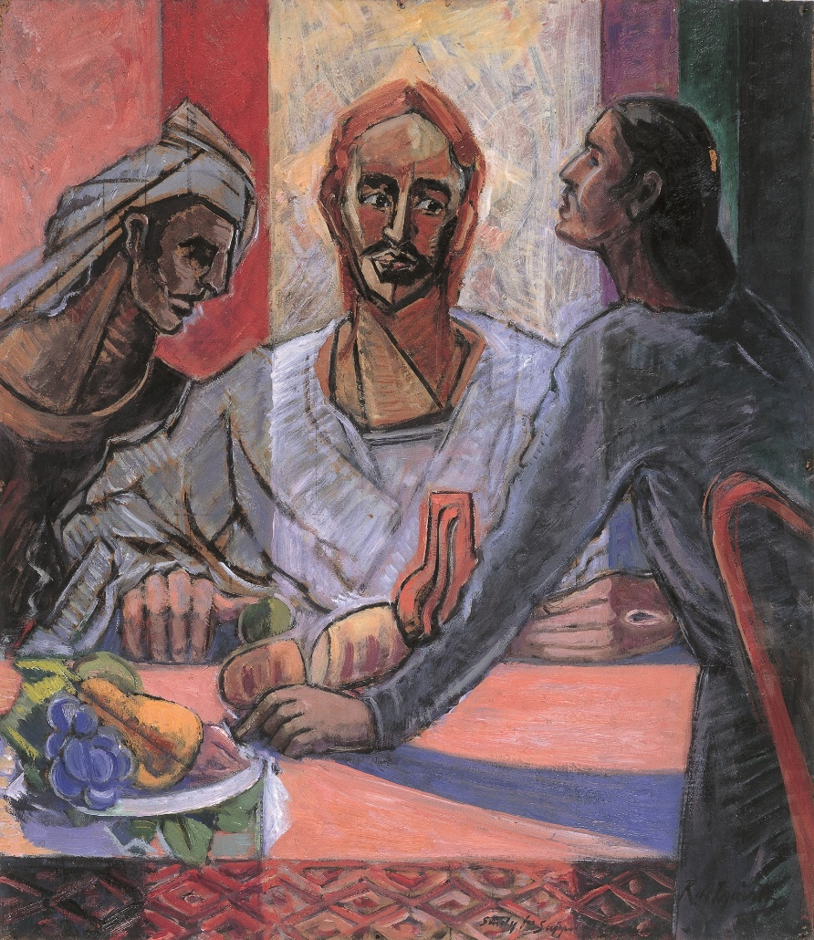

The painter of this picture De Maistre shows Jesus, in a white gown, positioned centrally at the table with one of his disciples on the left and the other sitting at the side of the table. Jesus is breaking the bread and has an apple (or some other green fruit) in front of him. More fruit lie on a plate or bowl on the table. The disciples are portrayed just as recognition dawns on them that their companion is Jesus. The wounds, the nail hole in Jesus’ left hand and the wound of the spear in his side are clearly visible and confirm their realization. In 1959, the artist commented: ‘religion is not merely a subject for a painting but a perpetual reality which has preoccupied me ever since I remember and is inseparable for me from every other thought’.

Can you place yourself in the picture.
Can you recall moments of revelation? The times when looking back you can see that Jesus was with you. Can you remember the times when a Bible passage spoke directly to you, so that it burned within you?
Speak with Jesus and allow him to become real and personal and alive for you.

Read: A Reflection / Prayer from Eddie Askew

They felt alone, Lord
as they walked towards Emmaus.
The stony ground, the dust,
the road, rutted and rough, meant nothing.
Neither did the stranger, coming from nowhere,
breaking in on their grief.
There was nothing left but memories
and they were still harsh and painful.
Time had had no chance to smooth the rough edges.
Their emotions were raw and bleeding.

Lord I don’t want to dramatize,
but I know how they felt.
I’ve stood in the wreckage of my plans,
seeing nothing but disappointment.
Shrugging my shoulders,
trying to pretend I didn’t care.
Turned off.
Then you appeared. Unexpected.
And the world was good again.
Not like Cinderella and the fairy godmother,
rags to riches, pumpkin to coach, mice into horses.
Not like that.
The pain didn’t suddenly disappear.
Outwardly there was little change,
but the air smelled fresher, the knots relaxed.
I began to function again,
to respond to people,
and to see you.
Lord it is good to know you are with me,
in all the struggles life brings.
In the disappointments and the difficulties
let me feel your presence.
And, Lord help me to share with others.
Make my presence with them your presence.
May your Spirit in me encourage and strengthen.
And as I recognise Jesus walking beside me,
may others see something of him in me.

Lord, thank you,
because you are always here.

Listen/sing

Living Hope - Phil Wickham https://youtu.be/u-1fwZtKJSM
Peace Be Still – Laura Daigle https://youtu.be/dUpKZz0Nm7c
STF 156 From the breaking of the dawn https://youtu.be/Y6PSsTq0YD8
What A Beautiful Name – Hillsong https://youtu.be/nQWFzMvCfLE

Pray
- For all finding life a struggle that God will journey with them and that they might know of his presence in their situation.
- For those who are responsible for making important decisions in our nation, our Government, our local authorities, that they too may know of the presence of the Lord and his wisdom.
- For all those “key workers” – all who work in our NHS, our emergency services, and those who are working to keep our country running and supplied.
- For those who are grieving the loss of loves ones. All those who are struggling will illness and who fear for the future.
- For those who are struggling with isolation and all those who are suffering from depression and despair…...that they might know of the light of hope. Ask that the peace and assurance of God will burn in their hearts.
- For our congregation at Brampton and Rev Heather Walker their minister.
- Lord, today I especially pray ….

The Lord’s prayer

Blessing

Let the majesty of the Father
be the light by which you walk,
the compassion of the Son
be the love by which you walk,
the presence of the Spirit
be the power by which you walk.

The embrace of the Father
Be the comfort you desire.
The name of the Son
Be the one on whom you rely.
The presence of the Spirit
Be with you every hour.
The Three in One
Be the focus of all you are.

