Worship for Sunday (for family worship - www.rootsontheweb.com/media/20312/12-apr-2020-childrens-sheet.pdf):

Pause in God’s presence

Loving God, our hope, our salvation rests in you. With open hearts we hear you call us by name from outside the tomb. We come to you and bring all of our care, all that causes us to be anxious, fearful, or inward looking. We thank you that in your resurrection we can find assurance, for you have conquered death and offer us life, and we can rest in your promise that as children of God we can never be separated from you.
But you ask us to go out in your resurrection power and strength, in the knowledge that you are with us and that we might testify in our words and actions to the hope and life that you offer. Come to us with your resurrection assurance and power that we might be people of light and hope and speak of the difference you make.

Savour God’s word: Read one or more of these passages and be alert to God’s invitation through them: Jeremiah 31 v1-6, Psalm 118 v14-24, John 20 v1-18, Acts 10 v34-43, Colossians 3 v1-4,

Explore God’s word – in this time how might you allow God’s word to shape you? In place of a sermon be creative and reflective. Here are just a few ideas:
Sit silently with a word of phrase from one of the readings

Imagine : Read the account of how Mary Magdalene meets the risen Lord in the garden of resurrection (John 20 v1-8).
Be present to her ability to see who is standing before her, as long as her grief laden search for all she has lost is dominating her consciousness. Then hear Jesus call her by name and notice how her focus changes. Nothing matters now except to discover anew the lost treasure and open her heart to whatever he will ask her.
As you reflect on this encounter, allow any memories of your own to surface of times when someone has spoken you name and broken through a veil of sorrow or fear, to bring new life. These are resurrection moments. Express your feelings to God about them in whatever way you feel drawn to do.

Look and think:

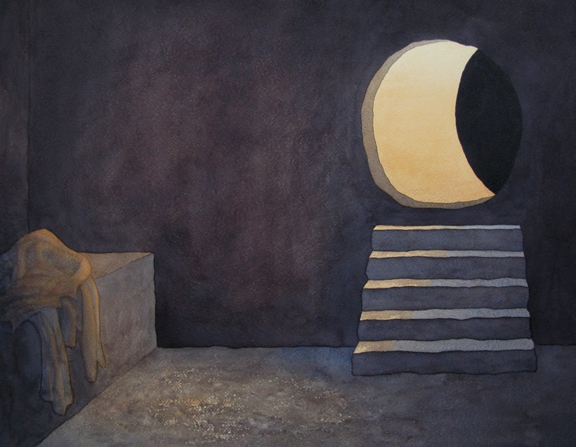

The painting places the viewer at eye level within the tomb, moments after Jesus has walked out into the garden in the warm light of the early morning. The grave-clothes lie in a discarded heap. In preparation for painting this work, Bavin read through the Gospel accounts of Holy Week several times as a prayerful meditation and found himself dwelling on the stillness and emptiness within the tomb moments after Jesus’ departure. ‘The absence was paramount: could I paint this space in a way that conveyed something of the magnitude of what had just taken place?’ The watercolours have been built up in many layers, working in the traditional way of starting with light colours and progressing to darker ones.

Can you place yourself in a time of stillness.
The tomb is empty – Jesus has walked out into the garden and the warm light of the early morning…. can you place yourself here, walking from the empty tomb to the light of Jesus presence as he calls your name.

Read: Poem by Adrian Plass
WHY DID HE CHOOSE?

What a mountain climber this Jesus might have been,
Climbing through the shadows of the scariest ravine,
Coming through and resting where the air is cold and clean,
What a mountain climber this Jesus might have been.

So why did he choose
Death on a hillside,
Agony under a merciless sky,
When he could have stayed at home,
Could have played with the thunder
Was I really the reason he decided to die?

What a stylish dancer this Jesus might have been,
Moving sweetly on the Galilean clubbing scene,
Dancing like a fire through red and gold and green,
What a stylish dancer this Jesus might have been.

So why did he choose
Death on a hillside,
Agony under a merciless sky,
When he could have stayed at home,
Could have played with the thunder
Was I really the reason he decided to die?

What a famous film star this Jesus might have been,
Up there with the others on the giant silver screen,
Showing all the others what a film could really mean,
What a famous film star this Jesus might have been.

So why did he choose
Death on a hillside,
Agony under a merciless sky,
When he could have stayed at home,
Could have played with the thunder
Was I really the reason he decided to die?

What a leg spin bowler this Jesus might have been,
A holy Rowley Jenkins on some Jewish village green,
Curling like a snake, and taking five for seventeen,
What a leg spin bowler this Jesu might have been.

So why did he choose
Death on a hillside,
Agony under a merciless sky,
When he could have stayed at home,
Could have played with the thunder
Was I really the reason he decided to die?

What a loving father this Jesus might have been,
Walking by his lady with the children in between,
Something in their faces that I have never seen,
What a loving father this Jesus might have been.

So why did he choose
Death on a hillside,
Agony under a merciless sky,
When he could have stayed at home,
Could have played with the thunder
Was I really the reason he decided to die?

Listen/sing

Thine Be The Glory https://youtu.be/bPjTfw4a2ZE
O Praise Your Name – Hillsong Worship https://youtu.be/LqBpifDpNKc
In Christ Alone – Celtic https://youtu.be/8kvFtXphmMU
See What a Morning (Townend & Getty) https://youtu.be/z0aKC3KxTb0

Pray
- For all who are offering acts of kindness in these days;
- For places of conflict and need, near and far;
- For those who need to hear the message of resurrection and hope – for all who have lost hope, the weary, the burdened and the ill;
- For our Government and especially Boris Johnson our Prime Minister
- For our congregation at Warboys, and Nick their minister;
- Lord, today I especially pray ….

The Lord’s prayer

Create: Make an Easter garden scene in an old shoe box or larger box and then take a picture of it and send it in to the Circuit website via: snhmcc@outlook.com

Blessing
May you find in Christ our risen Saviour, a faithful companion, a hopeful presence, peace that passes understanding and joy in knowing life is eternal.

The Lord bless you and keep you, those who you love and those for whom you pray. Amen.

