Printed material for Sunday 17th October 2021
Compiled by Rev James Bamber

Pausing in God’s presence
Take a moment to be still and know God meeting you as you are.
‘Not to us, Lord, not to us but to your name be the glory, because of your love and faithfulness.’ Psalm 115:1

Opening Prayer
Loving God, always near to each as we set this special time aside, may we feel your presence, and through the power of your Holy Spirit, may we know ourselves connected to all who worship you this day. [Pause].
Make us alive to your Holy Spirit that through all we share we might receive and reflect your grace more fully. Amen.
Hymn: May the Glory of the Lord Fill His Temple (StF 31) or HP 36: God is love
Sing/ Read /pray /proclaim the words or listen to Mark 6 here https://www.youtube.com/watch?v=FjpVwl-Ecfs

May the glory of the Lord fill his temple
as we gather in this place,
may the glory of the Lord touch his people
as we meet here by his grace.
Weak though we are, you lift us from sin,
where our hearts wait you long to come in,
so Lord we pray let your healing begin --
send us your Spirit today!
May the glory of the Lord fill his temple,
and may we meet him face to face.
Jonathan Nowell
Let us pray together
Gracious God we praise you for who you are giver and sustainer of all life, you are love. Thank you that even when we go own way and turn from you, you never forget us, your unquenchable love seeks us out. Thank you for the gift of Jesus. Thank you for the Holy Spirit which connects and joins us May we be attentive to your word that as it sinks deep into 6our beings we might be transformed by your grace and become Transformers in your world. Amen
Bible Reading: Mark 10: 35-45
Travelling with an image
Sit for a moment with the image below. What connects it to the Bible Reading for you? What is God’s invitation through it?
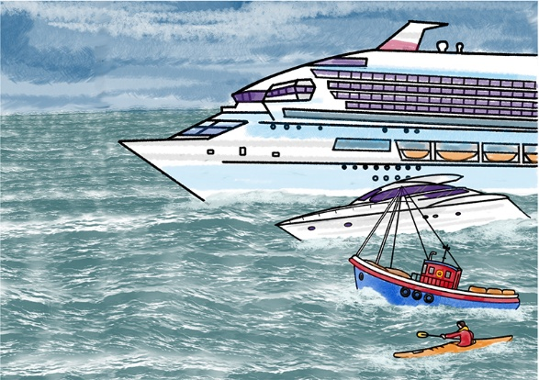
© ROOTS for Churches Ltd www.rootsontheweb.com
Reflection (from The Vine)
The two ‘Sons of Thunder’ (James and John) have appeared from time to time along with Peter as the small group with whom alone Jesus has shared and will share some of his most private moments. The three of them with Andrew were the first disciples called to follow Jesus, and they are mentioned together at the head of the list of the twelve in chapter 3 of Mark’s gospel. So they can reasonably think of themselves as leaders in the group. But it has been Peter who has taken the lead and acted as spokesman for the group on several occasions. James and John may well have begun to feel overshadowed, and decided that it was time to assert their position. Hence this bizarre approach to
Jesus.

The request for the seats beside Jesus in his glory could hardly have come at a more incongruous moment. He has just spoken not of glory but of humiliation, rejection and death. Perhaps they have picked up the words about rising again and are beginning to see that there may be some ‘glory’ beyond that death. Or, perhaps more likely, they may have simply fastened on the title ‘the Son of man’ with its associations of glory in the Old Testament, and filtered out the less welcome parts of what Jesus has said about how the mission of the Son of man is to be achieved. For whatever reason, they do seem to have put their foot in it rather seriously, and Jesus is not slow to point out to them the unwelcome implications of their request.

The glory is to be real enough, but the way to it is through suffering, which Jesus refers to as a cup to be drunk and a baptism to be endured. If they want to share the glory, they must share the suffering too. Jesus’ question in verse 38 sounds like a rhetorical question, and it is a surprise to find that it is answered at all, let alone that it is answered positively. The glib assurance of their reply ‘We are able’ is breathtaking, but perhaps it betrays not so much a conscious claim to be ready and able to share all that Jesus will undergo as a still inadequate grasp of what he has been talking about.

One day they will indeed suffer in their turn, James as one of the first Christian martyrs and John, according to tradition, as a prisoner on the isle of Patmos. But that suffering will not in itself earn them the places of honour which they covet. ‘Promotion’ in the kingdom of God is not won by aggressive self-presentation or even by martyrdom. It is for God, not us, to determine how its ‘honours’ are distributed. In the light of this chapter so far, we may be sure that it will not be on the sort of basis that human society takes for granted. It will be the little ones who will be the greatest in the kingdom of God.

‘It is easy to pour scorn on the crass self-assertion and self-interest of James and John. But how far have we, after two thousand years to absorb the values of the kingdom of God, even now managed to escape from the world’s concepts of status and importance?’ (Dick France, Mark: The People’s Bible Commentary)

I’ll leave you with a story to savour: It was her pride and joy. The gleaming new jaguar a treat to herself for landing a high profile job at such a young age. As she drove drown the unfamiliar residential street she kept her foot on the accelerator and her eyes open in case any children ran out from behind the parked cars. Suddenly – smash – a brick hit the passenger door – disaster! She slammed on the brakes, jumped out of the car, ran to the pavement and grabbed the boy who was standing there. ‘Why on earth did you do that?’ she demanded. In between his tears the boy mumbled, ‘Because no-one would stop.’ Pointing a few metres down the street he continued, ‘My brother has fallen out of his wheelchair and he’s hurt. I can’t lift him because he is heavy.’ Instantly the woman’s attitude changed. She ran to the injured boy, lifted him into his wheelchair, tended his wounds and helped to push him home.’ She never repaired the dent on her car door choosing to keep it as a visible reminder that true greatness lies not through wealth, status or power but service.
In Jesus company May we travel with an alertness to take every opportunity to serve without thought of reward for ourselves.
Hymn: May the mind of Christ my Saviour (HP 739)
Prayers for Others (from ROOTS)
When we seek power and glory for ourselves
and overlook the needs of the humble and weak,
Christ, the servant king:
Help us to follow your example of service
Where there are those who rely on food banks and on benefits,
Christ, the servant king:
Help us to follow your example of service

Where stronger nations ignore the plight of the poor; where food and medical supplies are stockpiled while others cry out in need.
Christ, the servant king:
Help us to follow your example of service
Where churches focus on their own desires
and fail to see the needy at their gates.
Christ, the servant king:
Help us to follow your example of service
When our neighbours are sick, imprisoned by addiction, cold through lack of shelter, lonely through isolation or tearful because of bereavement,
Christ, the servant king:
Help us to follow your example of service
When our personal ease and comfort leads us
to ignore the threats to the future of our planet,
Christ, the servant king:
Help us to follow your example of service
Loving God,
we pray that our society may become characterised
by our desire to serve one another;
to help the weak and seek the common good.
Help each one of us to work out our place
in the community of those who follow Jesus.
In the name of Jesus we pray.
Amen.
The Lord’s Prayer
Our Father ……
Hymn: Jesus, Jesus, show us how to love (HP 145)
A prayer of blessing
God to enfold you,
Christ to uphold you,
Spirit to keep you in heaven's sight;
so may God grace you,
heal and embrace you,
lead you through darkness
into the light.

John L. Bell (b. 1949)
Reproduced from Singing the Faith Electronic Words Edition, number 648
Words and Music: From Love and Anger © 1997, WGRG, Iona Community, Glasgow G2 3DH Scotland. <www.wgrg.co.uk>
Original Materials by Rev’d Andrew M Emison

