Worship sheet for Sunday 4th April 2021 (Easter Sunday)
Compiled by Colin Webber of Berkley Street Methodist Church, S Neots

Alleluia, Christ is risen!
Luke 24.1-3
On the first day of the week, very early in the morning, the women took the spices they had prepared and went to the tomb. They found the stone rolled away from the tomb, but when they entered, they did not find the body of the Lord Jesus.
HYMN: StF 98/H&P 193
Christ the Lord is risen today
https://www.youtube.com/watch?v=jfNwvNhpkN4

PRAYERS OF THANKSGIVING & CONFESSION
Almighty God, today is the most special of days – a day of victory, celebration and praise. A day on which we remember your great triumph – the defeat of evil, suffering and death. A day on which we recall the transformation you have brought – joy after sorrow, hope after despair, faith after doubt. A day on which we give thanks for all you have given us – love, laughter, life!

Almighty God, forgive us that we lose sight of those truths. We are so quick to become disheartened. We so easily forget all you have dome for us. Forgive us for the limits we set on your love. Forgive the feebleness of our response. Forgive the smallness of our vision.

Speak to us through this joyful season, and fil us with greater trust and deeper faith. So, may we live not just for this day but every day as your Easter people, through Jesus Christ our Lord. Amen.

READ LUKE CHAPTER 24 IN FULL
PICK AND MIX HYMN(S)
StF 297/H&P 190 - Christ Is alive, let Christians sing
https://www.youtube.com/watch?v=fD8pxDgTZZU
StF 295/H&P 250 - Alleluia, alleluia, give thanks to the risen Lord
https://www.youtube.com/watch?v=DyPYJtxu8cE
StF 301/H&P 222 - Hail thou once despised Jesus
https://www.youtube.com/watch?v=zexZ2XxogZo
StF 305/H&P 202 - Low in the grave he lay
https://www.youtube.com/watch?v=CtxSWcfH9hk
StF 303/H&P 196 - I know that my Redeemer lives
https://www.youtube.com/watch?v=SkLuZxqPPzE

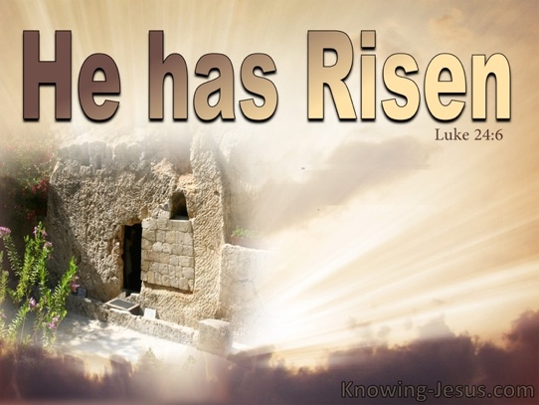
REFLECTION
Luke 24.6-8
He is not here; he has risen! Remember how he told you, while he was still with you in Galilee: ‘The Son of Man must be delivered over to the hands of sinners, be crucified and on the third day be raised again.’ Then they remembered his words.

Remember how he told you! How quickly the closest followers of Jesus forgot his words (Luke 9.22, 44, 18.31-33 and elsewhere in the gospels) having failed to fully understand them in the first place. The women remember and rush to tell the disciples, who do not believe them. However, everything Jesus promised them came to pass, even His mind-blowing death and resurrection. On that basis it should be easy for Christians today to have faith … and yet, so often we find ourselves waiting impatiently for God’s promises to be fulfilled. We may feel the darkness of disappointment or even despair as we feel our expectations have been dashed. The resurrection of Jesus gives us hope that everything God has promised will one day be fulfilled – it will be as He has said and every tear will be wiped away.
With many questions still unanswered, we later find ourselves on the road to Emmaus as Jesus comes alongside two perplexed followers. He chastises them (and by implication all the apostles) as foolish and slow of heart to believe what was always there in the writings of the prophets – how we would love to hear His interpretation that day of the scriptures! If we genuinely seek Jesus, let us pray that he interprets his word to us, for only he can form God’s story within us and fill us with the hope of promises yet to come.

PRAYER OF PRAISE
In the silence of the grave, Lord Jesus, you restore our life.
In the darkness of death, you bring light to our grief.
In the destruction of the body, you heal our brokenness.
In the dawning of the new day, you shake the earth with a power no tomb can hold.
May we live in anticipation of you glory and rejoice in your hope, now and always. Amen.

LORD’S PRAYER

If you have access to the internet, find time to listen to this song circulating on social media:
https://www.youtube.com/watch?v=-j3NZEdHQaI
(Should this link fail, just search for An Easter Hallelujah by Cassandra and Callahan Star)

ACTIVITY
As this Easter season begins to unfold, take a closer look at the natural world around you (whether on TV, out of a window, in a garden or out walking) and thank God for the new growth that particularly inspires you and points to His potential and promise. Reflect on all God’s promises that come to mind (perhaps seek out more!) and rejoice in each of them, not least that He would die for us and be raised again on the third day. Then consider those people/places/situations you know of that cry out for awareness of God’s promises and bring them to Him in prayer.
HYMN: StF 313/H&P 212
Thine be the glory, risen, conquering Son
https://www.youtube.com/watch?v=bPjTfw4a2ZE
Luke 24.36
While they were still talking about this, Jesus himself stood among them and said to them, “Peace be with you.”
He is risen indeed! Alleluia!

