Worship Sheet – Sunday 16th August 2020

Entering God’s presence
“Be Still and Know that I am God.”
Sit back. Breathe deeply. Quieten yourself and listen to the noises around you; birds outside, the fridge humming, cars passing by, the neighbour working outside. Offer these things to God in thanks.
Father, I thank you for all there is in our world, natural and manmade. As I come into your presence, I celebrate them and praise you for them. Speak to me through all those things and through your Word today. Amen.

Prayer
Lord, I come before you and acknowledge that you are King of Kings and Lord of Lords.
I bow before you and recognise you as the one who is able to do great things.
I am sorry that I do not always recognise your call, your authority and might, forgive me and restore me.
I praise you for your grace and forgiveness.
Help me to place my faith and trust in you and help me to listen to your reply as I call out to you.

God’s word: Read one or more of these passages and allow time and space for God to speak though his word: Genesis 45:1-15, Isaiah 56:1,6-8, Psalm 133, Romans 11: 1-2a, 29-32, Matthew 15:21-28

Watch & Listen: https://youtu.be/LAHXmRnNykU
What did you notice as the passage was being read? Where was your attention drawn, how do you want to react? Give all your thoughts to God at this time and allow him to speak to you.

To savour:
- The Canaanite woman shows great persistence; she did not allow the disciples’ irritation or Jesus’ reply to put her off. She knew what she wanted / needed, and she trusted that Jesus could help. Pray that your faith may have something of her clarity and persistence.
- Like the woman in the gospel, come before Jesus bringing others in prayer. As you pray for those you love, grow an appreciation of their goodness and ask for blessings for them. Think again of how they are blessings for you and give thanks.

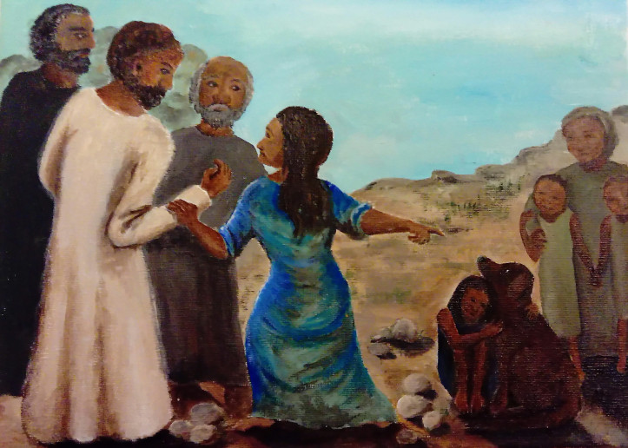
Look and think:

The painter @reverndally offers these insights into her painting on Matthew 15:21-28….note your reactions.
- On the left, there’s a small gathering of Jesus’ disciples, but they’re a group of individuals. On the right everyone is presented relationally. The woman, by touching Jesus, draws him into the relationality of her family. This, for me, is a mirror image of the usual pattern in which Jesus draws outcasts into relationality (often by touch).
- The stones on the floor are a recurring theme in scripture. Here, they stand for stumbling blocks – the stumbling blocks that Jesus warned about (in Mark 9), the stumbling blocks that we must not put in the way of ‘any of these little ones’. The woman demonstrates to Jesus that her daughter is indeed one of the little ones that come within Jesus’ sphere of protection and love.
- The woman is dressed in blue because her confrontation with Jesus reminds me of the way that Mary, his mother, showed him that his time had indeed come, and that it was the right moment for him to perform his first miracle (John 2).
- The older lady on the right is grandma, and she’s looking after her other grandchildren so that the woman is free to go and confront Jesus.
- I’ve always assumed that there was an actual dog. Dogs can enable people who wouldn’t otherwise engage with one another to reach a place of understanding and generosity.

Hymn: And Can it Be (Singing the Faith 345)
Sing/ Read /pray /proclaim the words or listen to it here: https://www.youtube.com/watch?v=29myH7xXI4M

- And can it be that I should gain
an interest in the Saviour's blood?
Died he for me, who caused his pain?
For me, who him to death pursued?
Amazing love! How can it be
that thou, my God, shouldst die for me?

- 'Tis mystery all:the Immortal dies!
Who can explore his strange design?
In vain the first-born seraph tries
to sound the depths of love divine.
'Tis mercy all! Let earth adore,
let angel minds enquire no more.

- He left his Father's throne above --
so free, so infinite his grace --
emptied himself of all but love,
and bled for Adam's helpless race.
'Tis mercy all, immense and free;
for, O my God, it found out me!

- Long my imprisoned spirit lay
fast bound in sin and nature's night;
thine eye diffused a quickening ray --
I woke, the dungeon flamed with light,
my chains fell off, my heart was free,
I rose, went forth, and followed thee.

- No condemnation now I dread;
Jesus, and all in him, is mine!
Alive in him, my living Head,
and clothed in righteousness divine,
bold I approach the eternal throne,

and claim the crown, through Christ, my own.

Charles Wesley (1707-1788)

A time of prayer
Re-read the last verse of the hymn. Take a time to sit quietly
“Bold I approach the eternal throne …”
I approach your throne for the people I know personally that need a special touch from you. I picture them as I place them into your loving hands.

I approach your throne for the people who are shouting out with questions and despair and don’t know where to turn. Be their comfort Lord.

I approach your throne for those far from me and give to you their needs, knowing that I can trust you to respond.

The Lord’s Prayer
Our Father ……

Listen & Sing:

What a friend we have in Jesus https://youtu.be/Prthhmly0Gg
Good Grace – Hillsong United https://youtu.be/lbwXAbH_GO0
I need thee every hour https://youtu.be/tZIMDcgrF-Q
My song is love unknown https://youtu.be/tZIMDcgrF-Q

Family worship for Sunday (for family worship: www.rootsontheweb.com/familiesathome16aug)

A prayer of blessing
In the joys, may I celebrate with you Lord.
In the troubles, may I shout out to you with boldness and listen to you in faith.
And in the everyday, may I journey on with you. Amen

