Sunday 19th July 2020

Opening Prayers
Everything God,
We know throughout the ages your people have worshiped you and proclaimed your greatness and your victory. We know that throughout the ages people have also cried out to you in sadness, grief and despair.
We come to you now to do the same….to worship you, to proclaim your greatness and to cry out to you.
Eternal God,
We are here, and you meet us where we are – wherever we find ourselves.
May we feel your love that stretches beyond borders and boundaries, giving hope even in the darkest of times. Unite us and remind us of your constant presence, so that we may face this day and the coming week with positivity, compassion and patience.
In Jesus’ name, we pray,
Amen.

God’s word: Isaiah 44.6-8 • Psalm 86.11-17 • Romans 8.12-25 • Matthew 13.24-30,36-43
Reflections on Matthew 13:24-30,36-43
The one who sows the good seed is the Son of Man...the good seed are the children of the kingdom. In a world that seems so closed to the Gospel, and which seems so often overrun by weeds, these words bring true reassurance. We can rely on the power and wisdom of the Son of Man, as we try to be good instruments and co-workers in his work. Pray for a trusting faith in the active presence of Jesus and of his Spirit in our world, and for courage and patience to do your part.
The field is the world. Jesus once said that the harvest is very plentiful. Pray for today’s world as it struggles to find its way in the new situation created by the coronavirus. Ask for the grace to be able to make a contribution to the spreading of the kingdom, together with others, wherever you are placed in this immense field of Jesus’ action.

Questions for further reflection:
What do you see in this image of wheat and weeds, where do you see ‘weeds’ and ‘wheat’ growing together in the world?
How might God be calling you to cope with the tensions this causes?

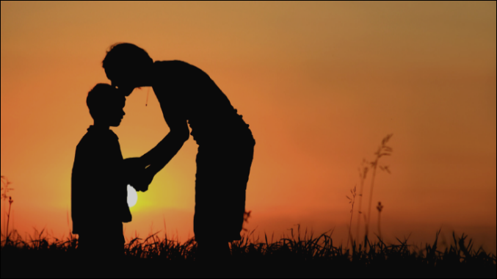
Look at the following picture:

You are a child of God. Rest for moment in this image.
What is God saying to you as loving Father. Listen to his encouragement and experience his love.

Prayers of intercession
We pray for the world around us; for the environment; for peace where there is conflict; for racial and social justice to be seen throughout the world.

We pray for our communities; for those who are shielding; for those who are fearful, for those working for the good of others in many different ways in our community.
We pray for all who work in the NHS and for all key workers and those on whom we rely.
We pray for our church community as we seek new ways of fulfilling our calling as the Church in these times.
We pray for our families, friends, and neighbours.
We pray for those who are ill and for those who are struggling financially or emotionally at this time.
We pray for those who are grieving as we remember those who have died.

In the stillness we take a moment to bring our prayers to God…

The Lord’s Prayer…..Our Father …

Listen & Sing:

No longer a slave to fear, I am a child of God (Bethel Music) https://youtu.be/f8TkUMJtK5k
To God Be The Glory https://youtu.be/-15v9iworAU
Who You Say I am (Hillsong) https://youtu.be/lKw6uqtGFfo
Amazing Grace https://youtu.be/CDdvReNKKuk

Family worship for Sunday (for family worship: www.rootsontheweb.com/familiesathome19jul)

Blessing:

The field is the world. Lord, I live in a tiny patch of your world but it is still my field to serve you. I pray that I will give my time and gifts to you and yours in whatever way I can. Your kingdom come, O Lord. Amen.

